Pizza Sales SQL Queries

KPI’s

Total Revenue:
Select SUM(total_price) AS Total_Revenue
From PizzaDB..pizza_sales
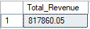

Average Order Amount:
Select SUM(total_price)/COUNT(Distinct (order_id)) as 'AVG_Order_Amount'
From PizzaDB..pizza_sales
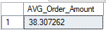

Total Pizzas Sold:
Select SUM(quantity) as Total_Pizza_Sold
From PizzaDB..pizza_sales
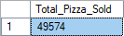

Total Orders
Select Count(DISTINCT(order_id)) as Total_Orders
From PizzaDB..pizza_sales

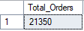

Average Pizza Per Order
Select CAST(CAST(SUM(quantity) as decimal(10,2))/
CAST(Count(DISTINCT(order_id)) as decimal(10,2)) as decimal(10,2)) as AVG_Pizza_Per_Order
From PizzaDB..pizza_sales

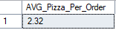

Charts

Daily Trend for Total Orders:
Select DATENAME(DW, order_date) as order_day
,COUNT(Distinct(order_id)) as Total_orders
From PizzaDB..pizza_sales
Group By DATENAME(DW, order_date)

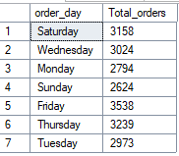

Hourly Trend:
Select DATEPART(HOUR,order_time) as Order_Hours
,COUNT(Distinct(order_id)) as Total_orders
From PizzaDB..pizza_sales
Group By DATEPART(HOUR,order_time)
Order By DATEPART(HOUR,order_time)

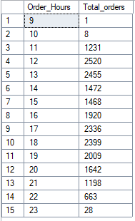

Percentage of Sales By Pizza Category For January:
Select pizza_category, SUM(total_price)*100 /
(Select sum(total_price) from pizza_sales Where MONTH(order_date) = 1) as Percent_of_sales
From PizzaDB..pizza_sales
Where MONTH(order_date) = 1
Group By pizza_category
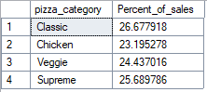

Percentage Of Sales By Pizza Size:
Select pizza_size, CAST(SUM(total_price) *100 /
(Select SUM(total_price) from PizzaDB..pizza_sales) as decimal(10,2)) as PCT
From PizzaDB..pizza_sales
Group By pizza_size
Order By PCT DESC

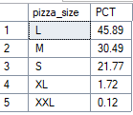

Total Pizza Sold By Pizza Category:
Select pizza_category,SUM(quantity) as Pizza_Sold
From PizzaDB..pizza_sales
Group by pizza_category

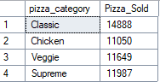

Top 5 Best Sellers:
Select TOP 5 pizza_name, SUM(quantity) as Total_Pizza_Sold
From PizzaDB..pizza_sales
Group By pizza_name
Order By Sum(quantity) DESC

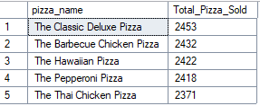

Bottom 5 Sellers
Select TOP 5 pizza_name, SUM(quantity) as Total_Pizza_Sold
From PizzaDB..pizza_sales
Group By pizza_name
Order By Sum(quantity) ASC

